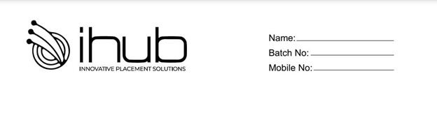

**Mock Test**

**Coding Questions**

1. **Write a java program to find out the given number is Armstrong or not?**
2. **Write a java program to find out the given number is Palindrome or not?**
3. **Write a java program to find out the Factorial of a given number using for loop?**
4. **Write a java program to check the given number is Prime or not?**
5. **Write a java program to display the Fibonacci series of a given number?**

**Input 5**

**Output 0 1 1 2 3 5 8**

1. **Write a java program to display the below loop pattern?**

**\***

**\* \***

**\* * \***

**\* * * \***

**\* * \***

**\* \***

**\***

1. **Write a java program to find out the Factorial of a given number using recursion?**
2. **Write a java program to find out the Nth element of Fibonacci series?**
3. **Write a java program to print the below output ?**

**Input:- int arr = {1,4,3,2,5};**

**Output:- 0,5,2,3,4**

**Hint:**

**Decrement the value based on odd index , increment the value based on even index**

1. **Write a java program to find out three highest elements from given positive integer array?**
2. **Write a java program to implement the concept of encapsulation with definition?**
3. **Write a java program to implement the concept of Polymorphism (MethodOverloading , MethodOveriding) with defination?**
4. **Write a java program to modify the string as below?**

**Input:- s = ”Talent”;**

**Output:- Tlnt**

**Hint:-**

**Remove the vowels and print the remaining characters present in the string**

1. **Write a java program to print the below output ?**

**Input:- A2B4C2**

**Output:- AABBBBCC**

**15.Write a java program to print the next character in a string ?**

**Input:- s =”Talent”;**

**Output:- Sbmfos**